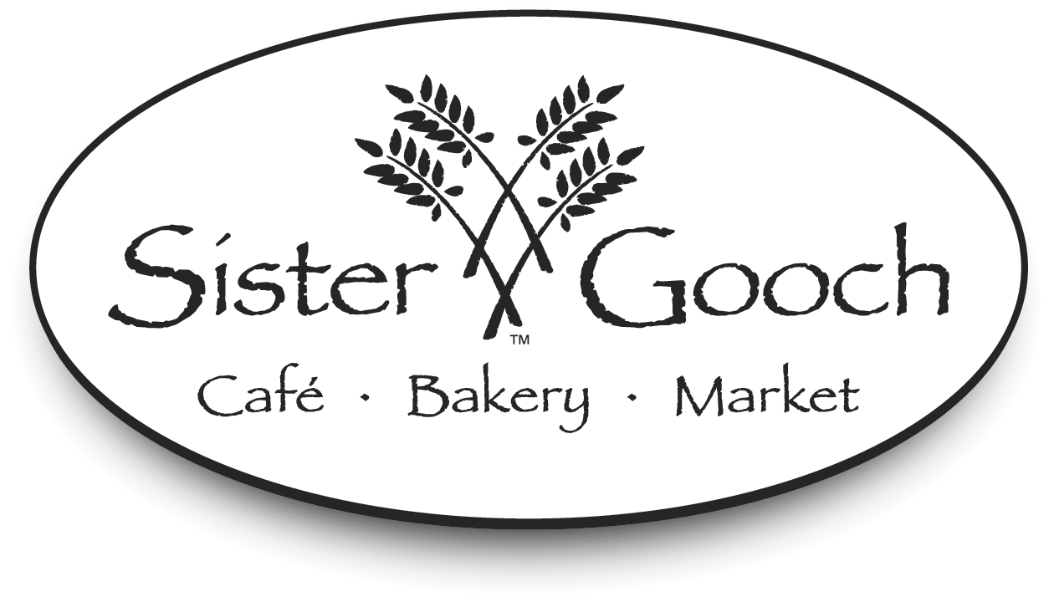
Merry Christmas
&
Happy Holidays!

382 Slaughter Road, Madison Alabama 35758
256 971 5200 voice / 256 971 5207 facsimile

Tuesday thru Saturday
10:00 am – 9:00pm

Dinner Reservations Suggested


The 2001
Madison
Community
Christmas Concert

Friday, December 7th
Bob Jones High School Auditorium




MADISON COMMUNITY BAND OFFICERS

S.A. HalePresident
Sue BartlowVice President
Robert SchwartzTreasurer
Elaine FarmerSecretary
Rachel ReinhardtLibrarian
Michael RyanStudent Representative

ACKNOWLEDGMENTS

Our Mistress of Ceremonies is Lee Marshall. Lee is the morning and noon anchor for WAFF 48. The Emmy nominated journalist has covered many issues in the valley. She is an adoption advocate and works to find Foster children forever families through her 'Kids to Love' program. In the past two years more than 80 children have found forever families through 'Kids to Love'.

While the news is her day job, music is her passion! Lee performed as her first solo in church at age 6 the great Southern Baptist Classic 'Learning to Lean'. Lee has been leaning on music ever since. As a music minor in college Lee received classical vocal training. Now she uses her voice to entertain at church, and civic functions.

Lee and her husband Jeff live in Southeast Huntsville with their dog Abby.
Mistress of
Ceremonies
The Madison Community Band wishes to recognize the following groups and individuals whose continuing support and dedication make each rehearsal and performance a reality:

- Asbury United Methodist Church and John Ryberg for providing MCB with a wonderful rehearsal area and equipment storage space

- WRSA LITE 97

- The Bandwagon

- Bob Jones High School

- UAH Department of Music

- Host of Christmas Past and Fayetteville Chamber of Commerce

- The citizens of Madison for their continuing support

- Our families for their constant support as we realize our dream of making music




The Madison Community Band is under the direction of Dave Ryan. Dave has been the conductor since the band’s inception in 1993. Since that time the Band has grown from fifteen to sixty-plus members and has been honored to perform at Huntsville’s Panoply of the Arts Festival, the US Space & Rocket Center, the Madison Street Festival, Lake Guntersville State Park, and the Lucy’s Branch July 4th Celebration among many others. We have several standing engagements each year such as the “Host of Christmas Past” concert in Fayetteville, our annual Concert on the Mountain at the Monte-Sano State Park Amphitheater, and the Concert by The River Series at Rhodes Ferry Park in Decatur.

MCB always welcomes new members of any age that share our love of music and community. We practice on Tuesday evenings at 7:00pm at Asbury United Methodist Church. MCB is a 501(c)(3) non-profit organization. For more information about us please visit our website at http://dc-vc.net/mcb/.

Mr. Stephen Charpie

Cornet Soloist

Mr. Stephen K. Charpie (Steve) earned his Artist's Diploma in Trumpet from the Manhattan School of Music in New York City. His principal teachers were Mel Broiles of the Metropolitan Opera Orchestra and Adel Sanchez of the National Symphony Orchestra.

Mr. Charpie spent four years with The United States Navy Band in Washington, D.C., where he was first trumpet and occasional soloist. After leaving the US Navy Band, he spent two years as first trumpet with the Walt Disney World Band in Orlando, FL. Moving to Los Angeles to further his career, Steve has played in the Disneyland Band in Anaheim, CA., and is a regular member of the Long Beach Symphony Orchestra. Steve also performs as needed with The Louisville Orchestra in Louisville, KY. He has done free-lance work for television, films, theatres, and symphony orchestras.

Steve’s interest in historic brass performance has led him to ongoing appearances with the Mr. Jack Daniel’s Silver Cornet Band, The New Columbian Brass Band (Danville, KY), The New Sousa Band, The California Gold Rush Band, and his newest project, The New Custer Brass Band. All of these bands have recorded. Mr. Charpie is in demand nationally as a soloist and lecturer on historic brass. Additionally, Mr. Charpie has many historic band and solo pieces that are published and that have been recorded. He is an authority on the history of early African-American musician, Francis Johnson. Much of his research has been published including the listing in the award winning International Dictionary of Black Composers.

Cornet solo performances have included high schools, colleges, museums, festivals, etc. Keyed Bugle performances include Northwestern University and the National Civil War Band Festival. Steve had two solo appearances on Baroque Trumpet with the Mozart Chamber Orchestra.

While in town, Mr. Charpie held a Recital and Narrative in Roberts Hall on the Campus of UAH, featuring music of the 18th and 19th centuries for the cornet, keyed bugle and baroque trumpet. He also held clinics at several local high schools including Bob Jones, Grissom, Huntsville, Lee, Austin and East Limestone. Students from all over Madison, Morgan, and Limestone counties attended these clinics.

THE MADISON COMMUNITY BAND

04/27/02 Panoply of the Arts Festival - Huntsville
05/11/02 SOS – Dublin Park - Madison
05/27/02 Memorial Day - City Cemetery, Madison
06/29/02 Concert on The Mountain – Monte-Sano State Park
07/04/02 July 4th Celebration – Dublin Park, Madison
07/15/02 Concerts By The River – Decatur
10/05/02 Madison Street Festival - Madison
11/09/02 Host Of Christmas Past – Fayetteville
12/06/02 Madison Community Christmas Concert -
Bob Jones High School, Madison
2002 CONCERT SCHEDULE

Madison Community Band's
GUEST PERFORMER



GUEST PROFILES

Emmanuel Singers’ ‘Children’s Fun Bells’

This energetic ensemble consists of third and fourth graders from Asbury United Methodist Church, directed by Melissa Campbell and Karen Pudelski. They rehearse and perform regularly and take pride in sharing God’s love with the community. They are a special joy and inspire the child in all of us to cherish Christmas in its’ purist form. Although they usually perform as a singing group, they will entertain us tonight with “Fun Bells”. Covering a single octave in range, these uniformly sized bells are designed for playing chords as coordinated by color flashcards.

CHRISTMAS PORTRAIT
SING-A-LONG

We Need a Little Christmas

“Haul out the holly.
Put up the tree before my spirits fall again.
Fill up the stocking.
I may be rushing things,
But deck the halls again now.

For we need a little Christmas
Right this very minute,
Candles in the window,
Carols at the spinet.

Yes, we need a little Christmas
Right this very minute,
It hasn’t snowed a single flurry,
But Santa, dear, we’re in a hurry.

So climb down the chimney,
Turn on the brightest string of lights
I’ve ever seen.
Slice up the fruitcake.
It’s time to hang some tinsel
On that evergreen bough.

For I’ve grown a little leaner,
Grown a little colder, Grown a little sadder,
Grown a little older. And I need a little angel
Sitting on my shoulder
Need a little Christmas now.

For we need a little music,
Need a little laughter,
Need a little singing,
Ringing through the rafter.

And we need a little snappy
‘Happy Everafter.’
Need a little Christmas,
Need a little Christmas,
Need a little Christmas, Now!”

End.
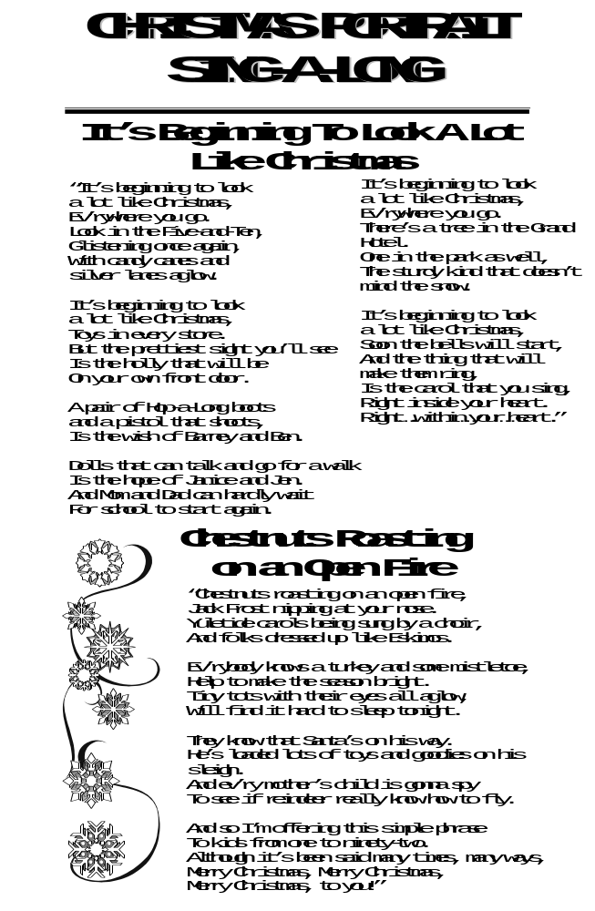
GUEST PROFILES

Huntsville Community Children's Chorus
The Huntsville Community Children's Chorus (HC3) began its first season in the fall of 1995. Established under the auspices of the Huntsville Community Chorus Association (HCCA, or the grown-ups), HC3 is open to all students in grades 4 - 9 with unchanged voices. The Chorus is dedicated to promoting the art of choral singing among area youth through the study and performance of only the finest music literature. Folk songs, carols, canons plus works by major composers comprise the repertoire of HC3.
Last year HC3 was invited to perform in the Piccolo Spoleto Festival held in Charleston, S.C. In 1999, HC3 produced an original adaptation of Englebert Humperdinck's operetta ‘Hansel and Gretel’. Additionally, the chorus has performed at the Panoply Festival, with the Brasher Chorale, Randolph School's Under the Christmas Tree, the Botanical Garden's Fall Festival, and singing the national anthem for the Huntsville Stars and Channel Cats sports teams. HC3 is pleased to return for the third year as guests of the Madison Community Band for this Holiday Concert.
This year, HC3 is mounting a production of Gilbert and Sullivan's operetta ‘H.M.S. Pinafore’ April 4th and 5th. The Huntsville Youth Symphony will be the show orchestra. Three performances will be given at Westminster Presbyterian Church in Huntsville. For information please call 461-6057 or 651-1815. HC3 is directed by Anne Chelekis with assistant directors Martha Brouse and Karen-Lynn Parker. Our accompanist is Janet Holland.











The Madison Community Band
The Madison Community Band
Huntsville
Community

Children's
Chorus

A CEREMONY OF CAROLS**- Benjamin Britten

I Procession (Hodie)
II Wolcum Yole!
III There is No Rose
IVa That Yonge Child Joshua Harper, soloist
IVb Balulalow Elizabeth Gillespie, soloist
V As Dew in Aprille Camerata Singers
VI This Little Babe Camerata Singers
VIII In Freezing Winter Night Camerata Singers-soloists
Nina Wilson, Katie Broad
IX Spring Carol Nina Wilson, Katie Broad
X Deo Gracias
Katherine Newman,
Harpist
SLEIGH RIDE – Leroy Anderson

A CHRISTMAS PORTRAIT*** – Jerry Nowak

GREENSLEEVES – Alfred Reed

CARNIVAL OF VENICE – J. Baptiste Arban,
Arranged by Donald Hunsberger

Featuring: Steve Charpie,

Cornet Soloist

HOW THE GRINCH STOLE CHRISTMAS – Larry Clark

*Tonight’s performance is being recorded for purchase.
Details for ordering your own personal copy are
available in the lobby.

**The audience is requested to refrain from
Applause between movements.

**Sing-a-Long Medley, words listed in program

2001

Madison Community Christmas Concert*

Program

-INTERMISSION-

THE MOST WONDERFUL TIME OF THE YEAR- Arr. John Moss
CHRISTMAS RECOLLECTIONS– John Edmondson
Frosty The Snowman
Santa Claus Is Comin' To Town
I Saw Mommy Kissing Santa Claus
Here Comes Santa Claus
Have Yourself A Merry Little Christmas
'TWAS IN THE MOON OF WINTERTIME- Robert W. Smith
A HOLLY JOLLY CHRISTMAS- Arr. by James Ployhar
UNA VOCE POCO FA-Rossini, Arr. by Charpie & Sons

BUGLER’S HOLIDAY – Leroy Anderson

Emmanuel Singers’

‘Children’s Fun Bells’

